**What is Jenkins ?**

* Jenkins is open source CI/CD tools.
* Jenkin developed in java programming language.
* Original author(s) 🡪 Kohsuke Kawaguchi
* Initial Release date 🡪 2nd Feb 2011

Initially it was developed for CI/CD by “Sun Microsystem” and it’s original name was “Hudson” and renamed in 2011 after dispute with Oracle which had forked the project.

**What is CI/CD ?**

* 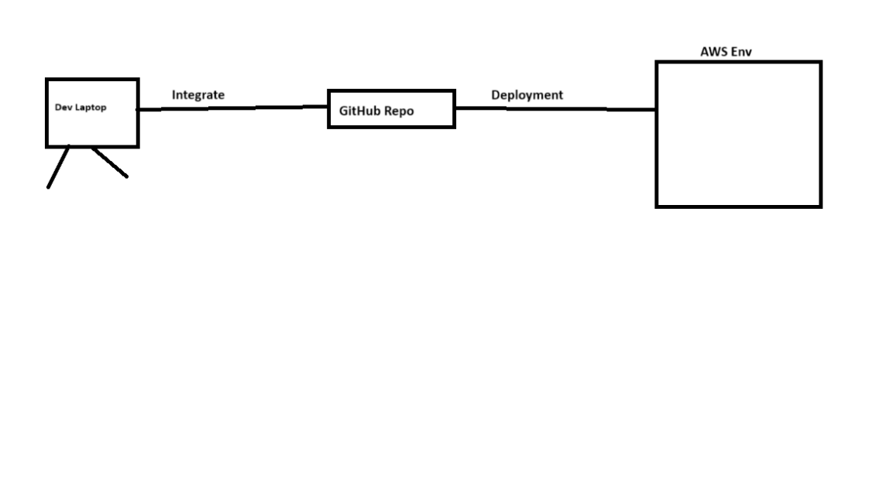**It is a continuous integration continuous deploytment**

**There are so many CICD tool available in the market**

* **Jenkins🡪 Most impt tool**
* **Circle CI**
* **Bamboo**
* **Gitlab CICD 🡪 it has more managing tools**
* **Github Action**

**Benefits of CI/CD**

* Automation Process
* Quick release process
* Reduce manual errors
* Improves organisation ability
* Less time
* Managing Multiple tasks
* Impelemnt Continuous process

**Note**

If we try to run Jenkins in an ec2 server we should go with “t2.medium” in AWS because it is not compatible with t2.micro.

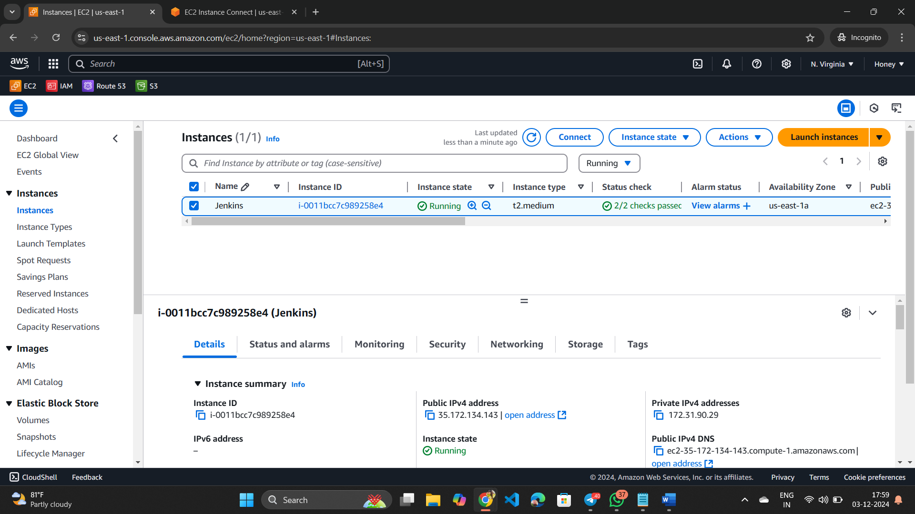

**Steps to install Jenkins and run it**

Step-1

* Create an Ec2 server in AWS
* Install Jenkins in Ec2 server

sudo wget -O /etc/yum.repos.d/jenkins.repo https://pkg.jenkins.io/redhat-stable/jenkins.repo

sudo rpm --import https://pkg.jenkins.io/redhat-stable/jenkins.io-2023.key

sudo yum install jenkins -y

sudo systemctl enable jenkins

sudo systemctl start Jenkins

* Install Java in Ec2 because Jenkins is developed by Java programme.

sudo yum install java-17-amazon-corretto.x86_64

* To check Jenkins is active or not try

Systemctl status Jenkins

* To run Jenkins use public ip of Ec2 server and add “:8080”
* 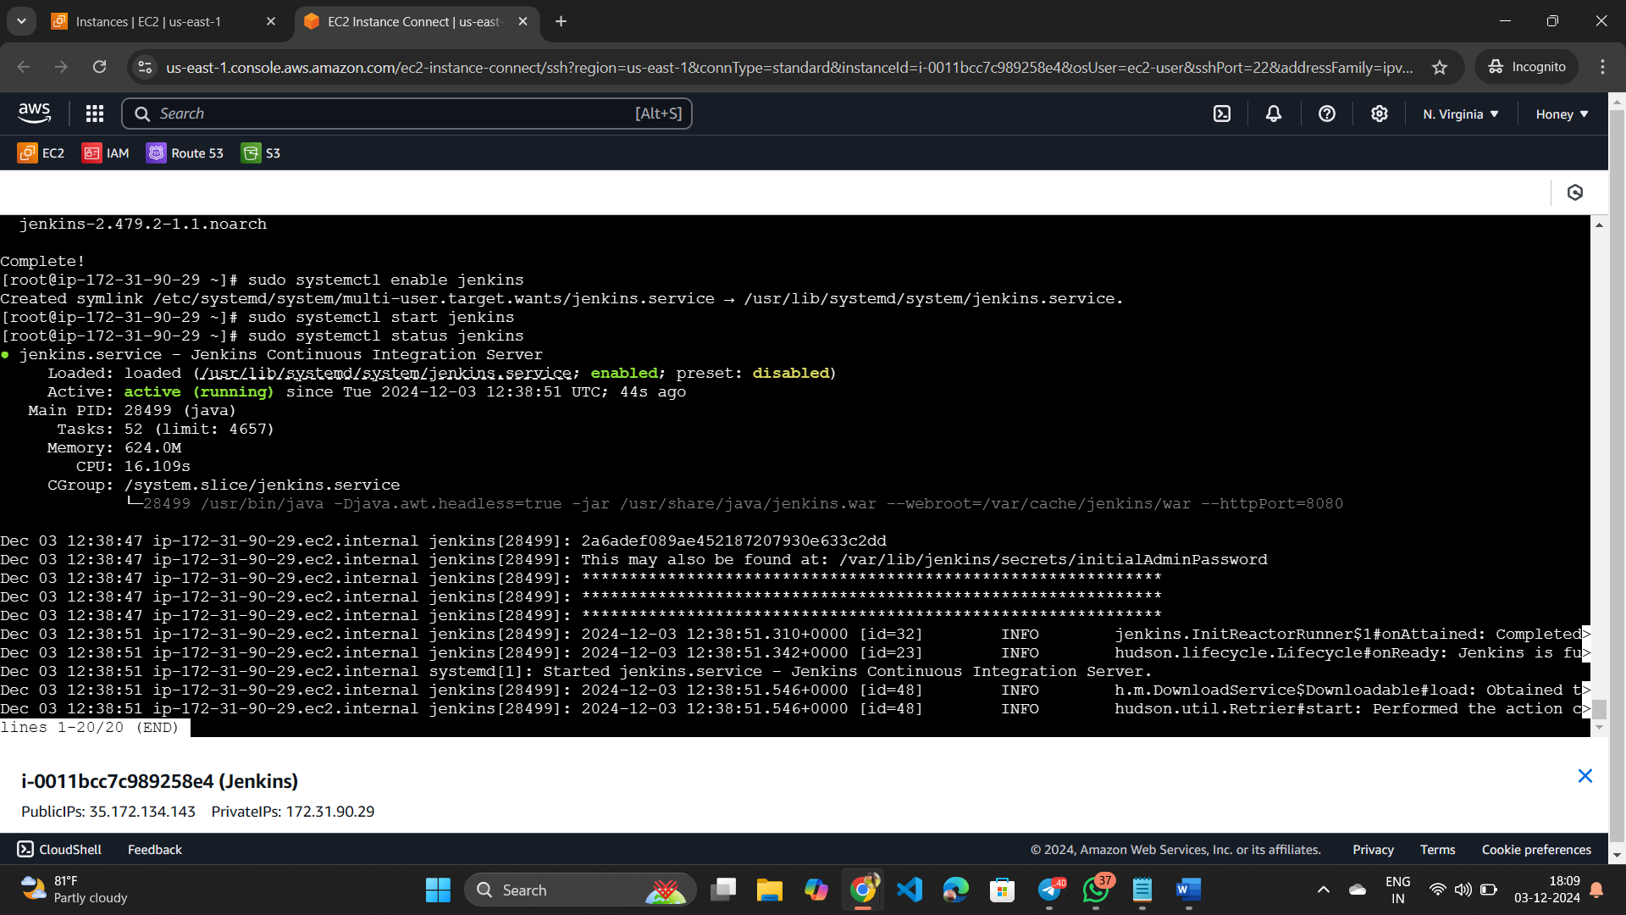
* While open Jenkins 1st time it will ask for password and give a path where password is store.
* We can check it by copy that path come to server and then try the command “cat and paste the path “ it will show you the password.
* After login click on “Install plugins” because Jenkins will work based on plugins after click on “install plugins” wait for some time.
* Then give the information .

P.S:- Don’t forgot password .if you forgot then the recovery and replacement of password process is very lengthy.

* After Login into Jenkins you will go to dashboard.
* 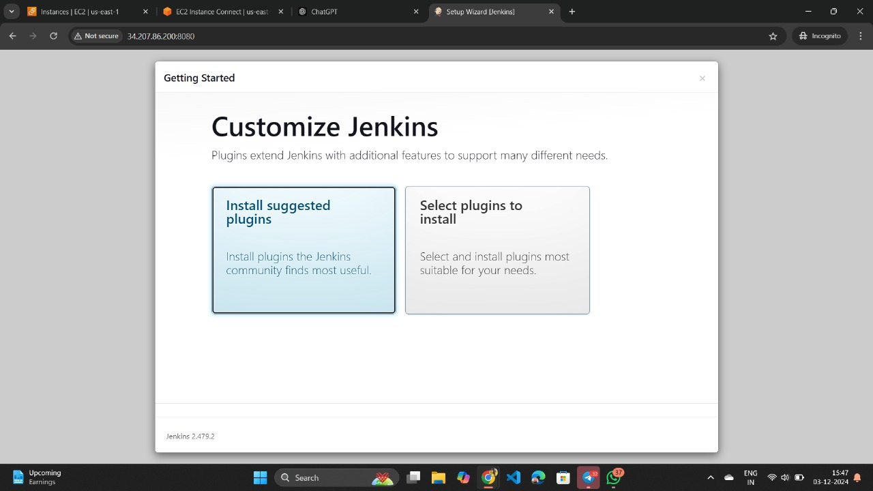

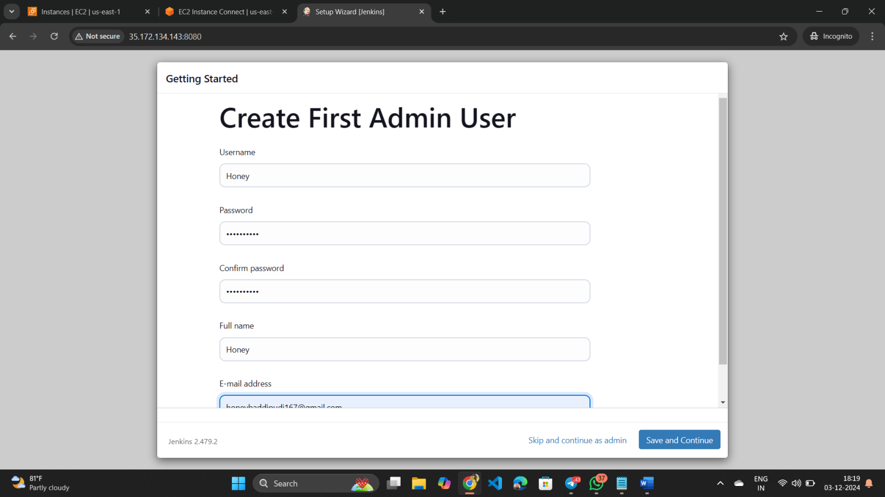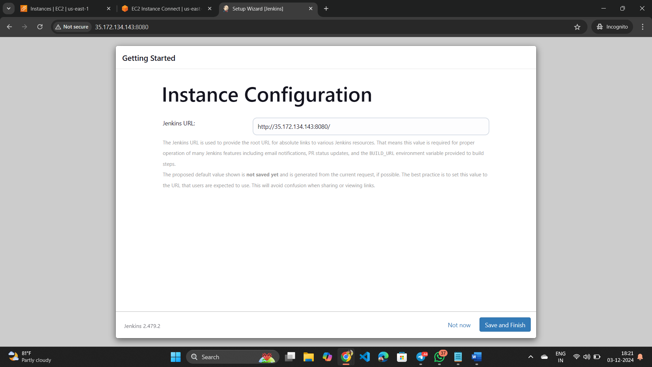

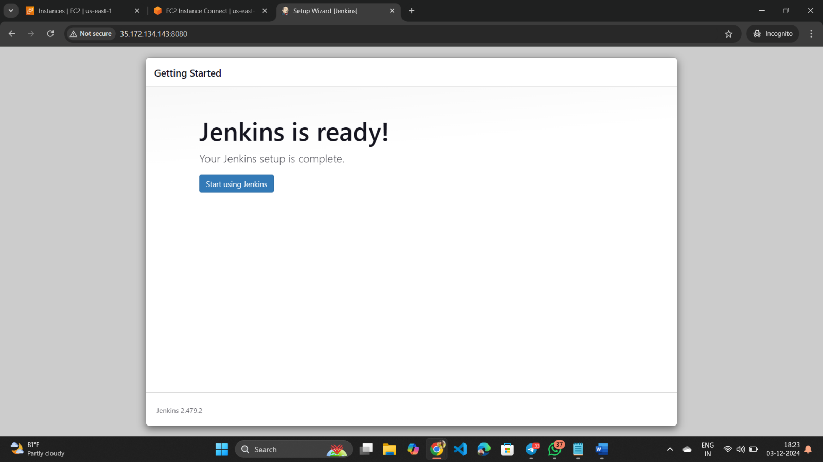

**Create a Pipeline**

* In the Jenkins dashboard in the lest side corner there is “+NewItem” present click on it then give a “Name” to it and then select pipeline option.
* After giving name & selecting “Objective “ we will go to the configuration section.
* Here we have 2 types of pipelines i>Declarative and ii>Scripted

i>Declarative means we will give the instruction

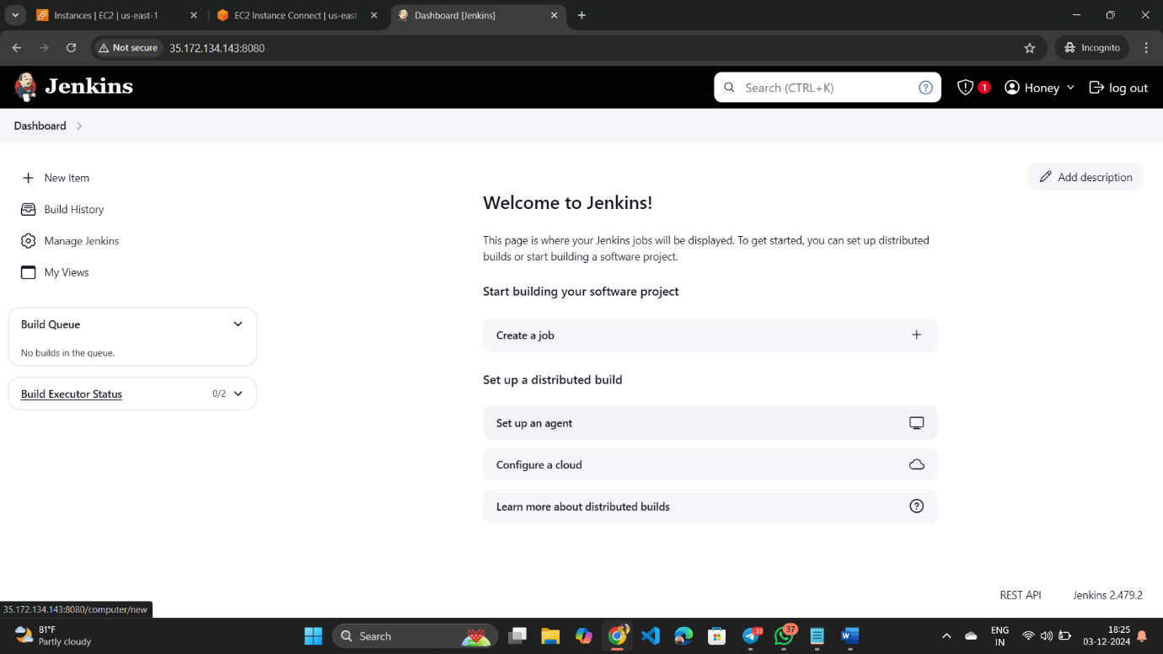ii>In Scripted we’ll get a template of a pipeline.

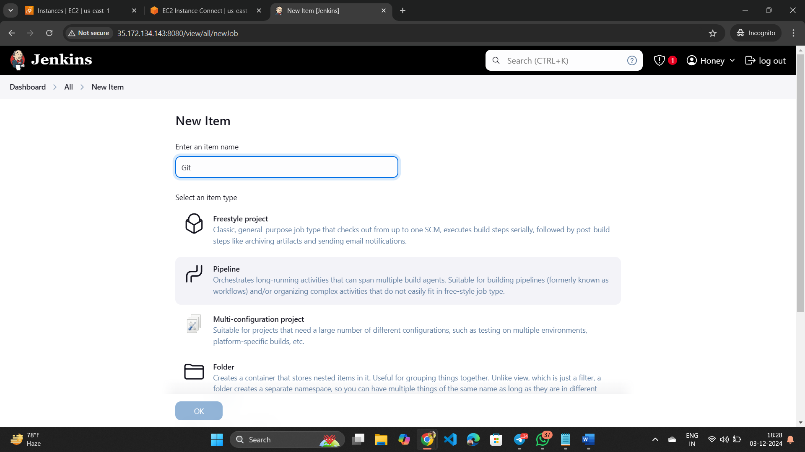

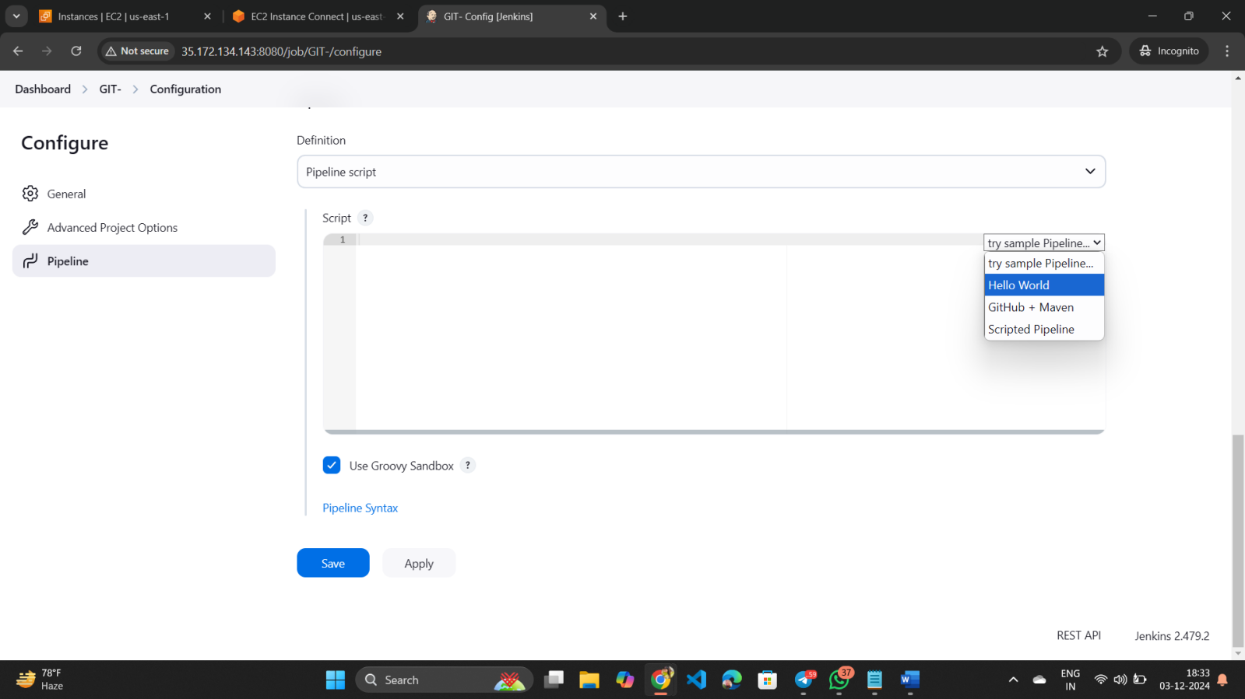

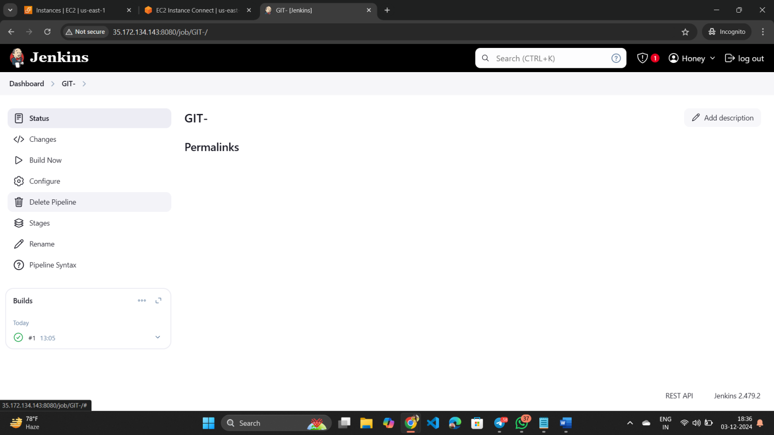

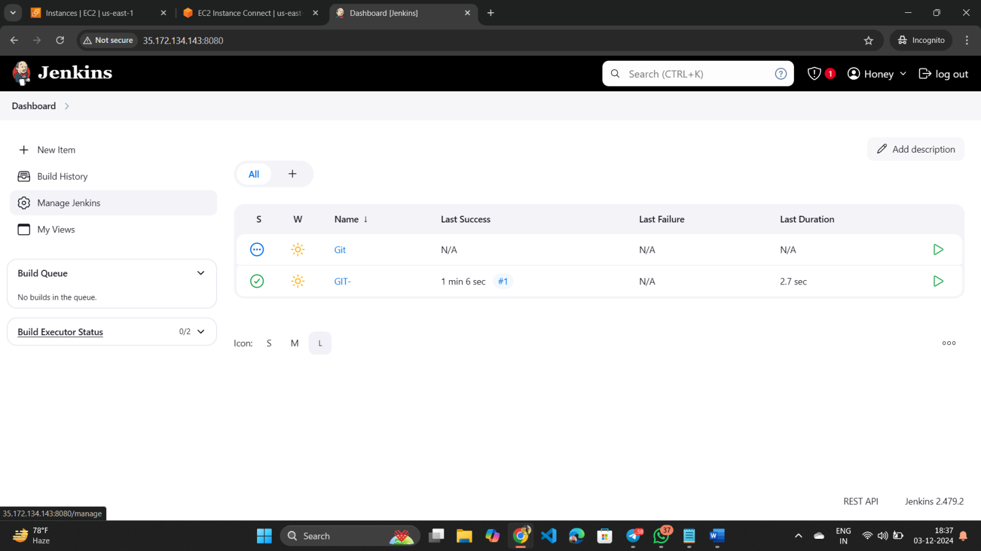

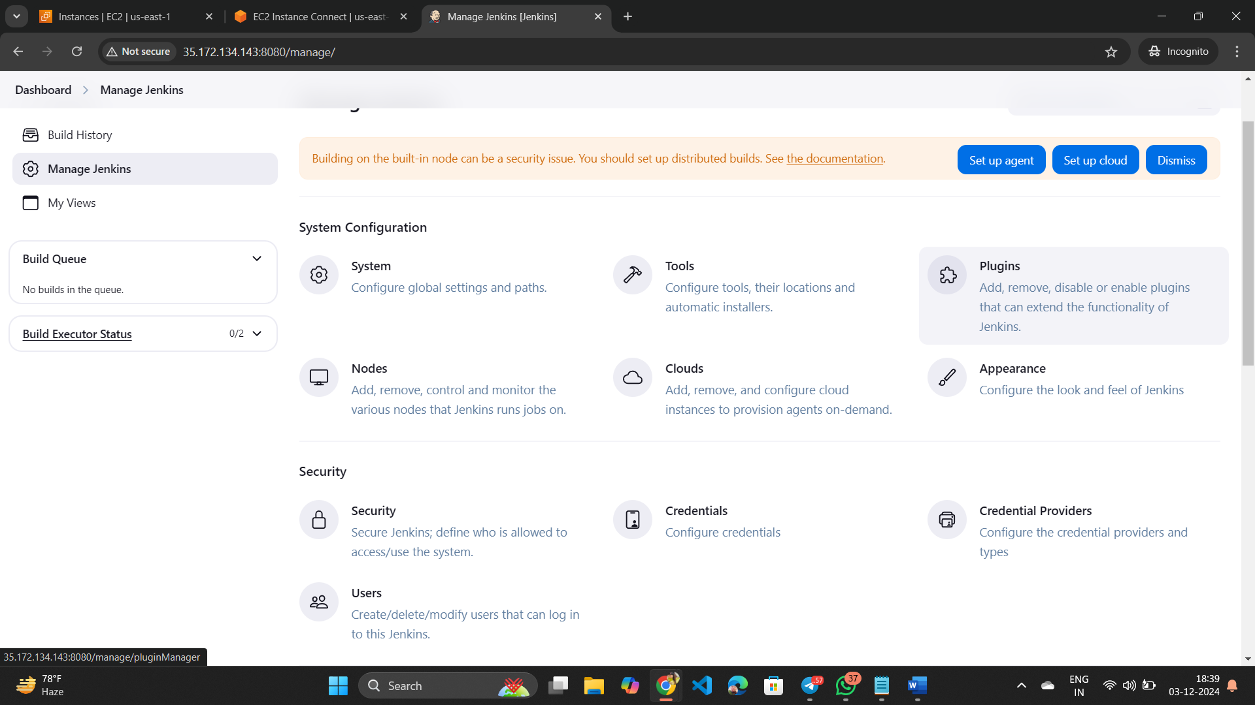

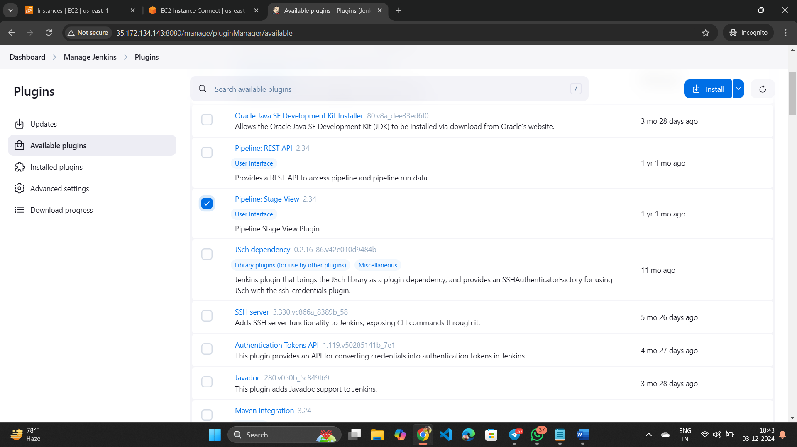

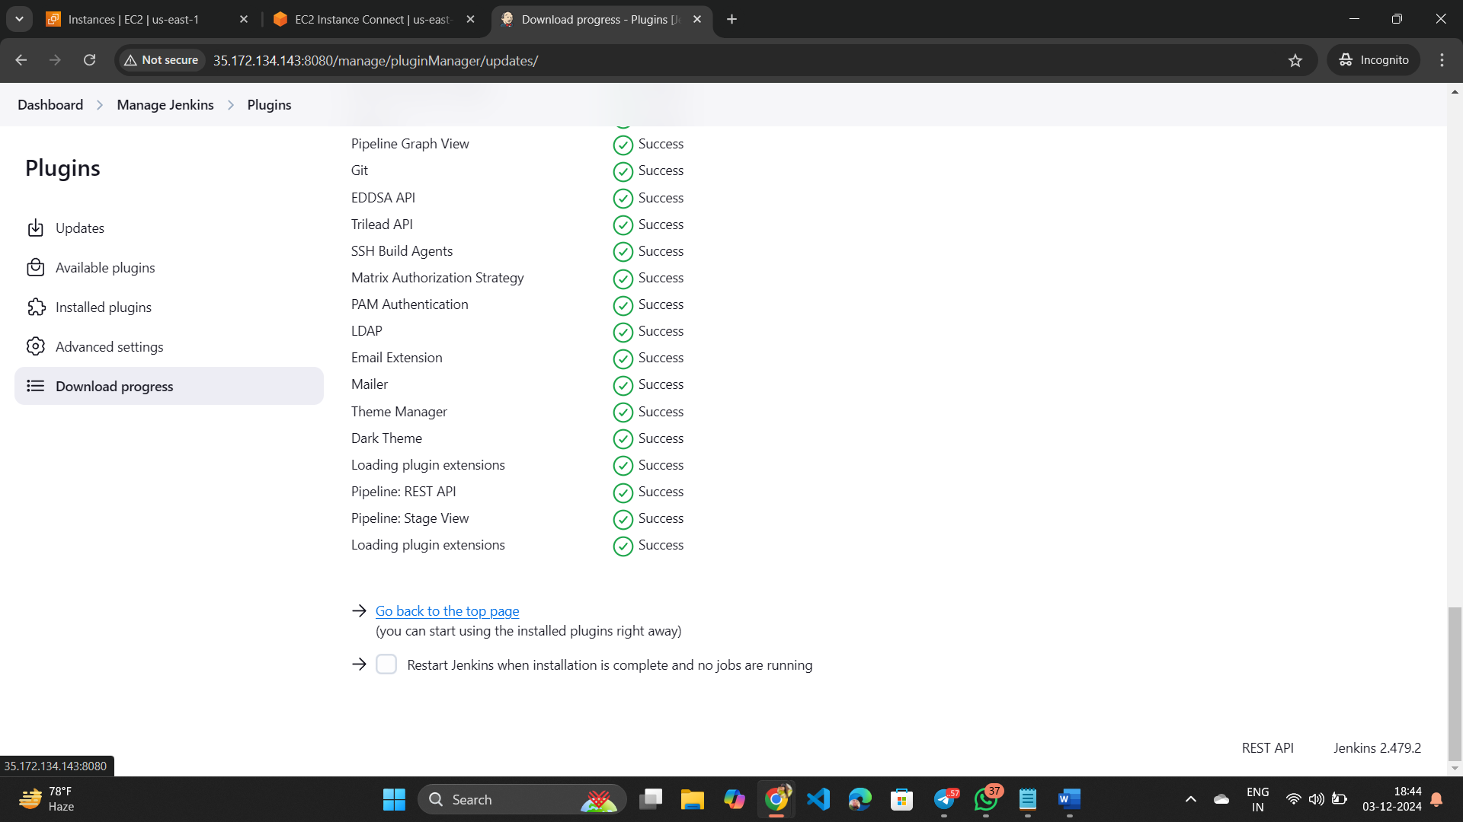

EX:-

In script section select “Hello World” script . (it’s a declarative one). It will give us a “hello World” Pipeline template.

**Script**

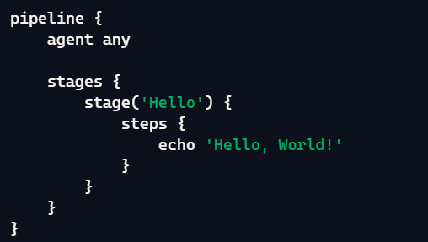

Then click on “apply” and “save” and then click on “build now.”

Now here it won’t show you anything so to solve this we will install plugins.

* To install plugins we’ll go to manage Jenkins.
* Available plugins 🡪search “pipeline:stage view”🡪install🡪go back to the top page🡪click on item(the name you gave).
* 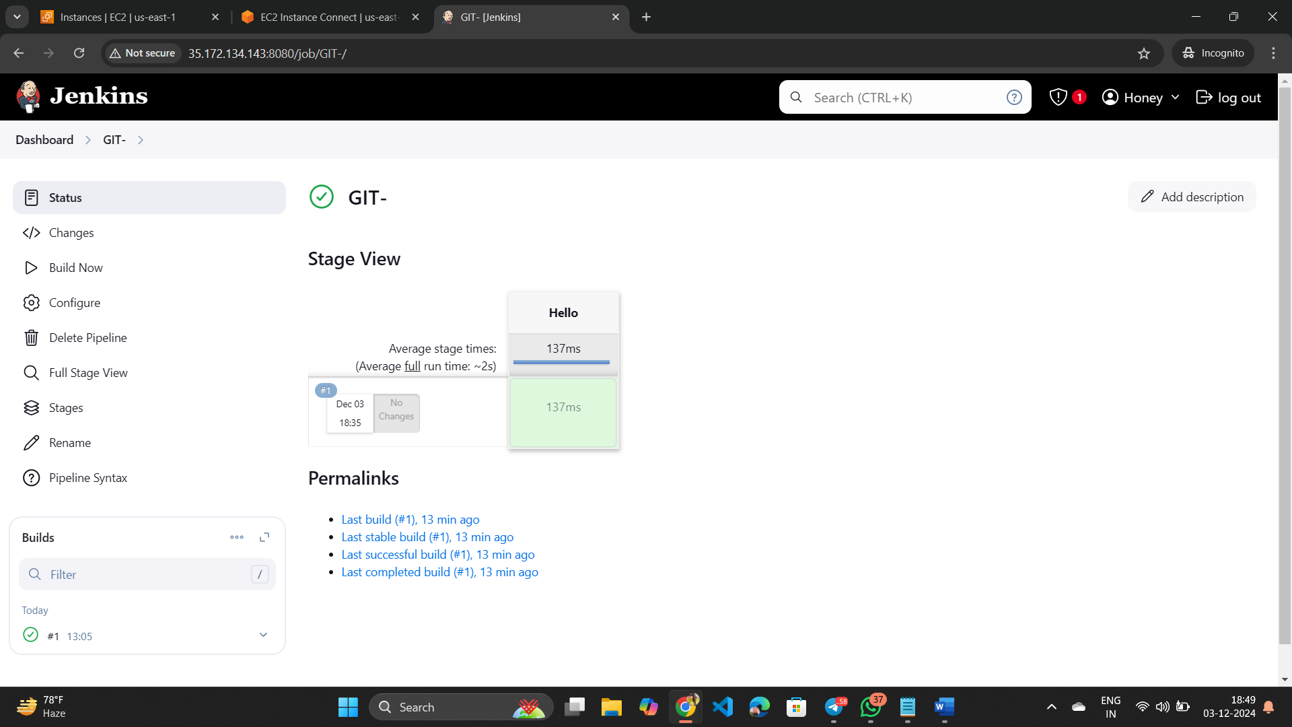

**How too clone Git Repo in JENKINS**

* Before clone git repo in jenkins first install git in the same server where we install Jenkins.

P.S:- We can do it through Jenkins also but for beginners we will do it manually in Ec2 server.

sudo yum install git -y

* We will create a script for git clone in Jenkins
* In configure page below “script“ there is a “pipeline syntax” click on it.
* In sample step select “Git:git”🡪paste “Repo URL”🡪give the branch “main/master” (in my case it is main branch”🡪click on “Generate Pipeline script”🡪then copy the generated script” and paste it inside stages.’

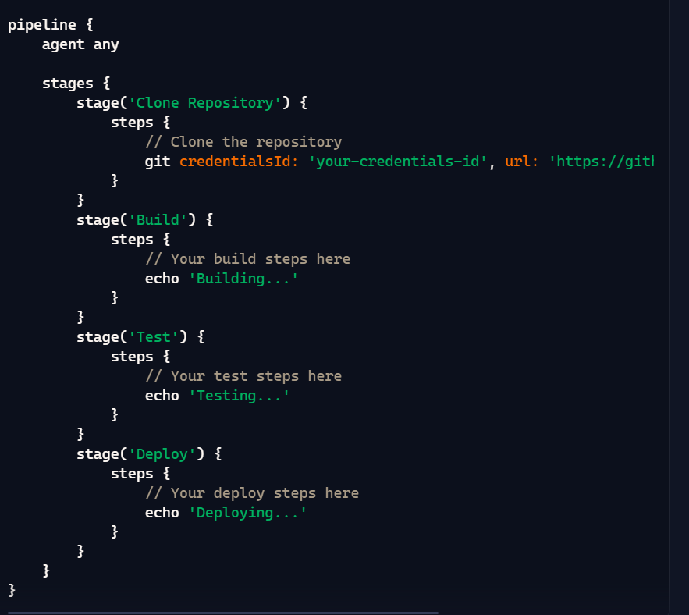

* Then apply and save it.

Terraform **in Jenkins**

* Before run terraform in Jenkins install terraform inside same server where jenkins was installed.

sudo yum install -y yum-utils

sudo yum-config-manager --add-repo https://rpm.releases.hashicorp.com/AmazonLinux/hashicorp.repo

sudo yum -y install terraform

* After installing terraform in the Ec2 server you can run terraform init, plan , apply through Jenkins.

Ex:-

Stage(‘terraform’){

Steps {

Sh ‘terraform init’

}

}

Stage(‘terraform’){

Steps {

Sh ‘terraform plan’

}

}

Stage(‘terraform’){

Steps {

Sh ‘terraform apply -auto-approve’

}

}

Stage(‘terraform’){

Steps {

Sh ‘terraform destroy -auto-apprrove’

}

}

* In the last 2 steps we add “-auto-approve” because in terraform when we apply/destroy . it is asking for approval. In Jenkins middle of the operation we can’t give approval so we use “-auto-approve” otherwise it will through an error .

Note:-

When we run terraform in Jenkins in the same server attach the IAM role to the server (ec2 admin).